**Project Name: Amadeus Assignment for Data Scientist Business Intelligence**

* Done by: Jim Harrington JSN
* Number of questions: 5 (3 Mandatory and 2 Bonus)
* Technology used: Python
* Libraries used: Pandas, Seaborn, Mathplotlib and PyWebio
* GitHub URL: <https://github.com/jimdatapro/-jimdatapro-Amadeus-Assignment-Solution-Code>
* Python solution notebook for exercise 1 to 4 file name: solution_code.ipynb
* Python solution notebook for exercise 1 to 4 link: <https://nbviewer.jupyter.org/github/jimdatapro/-jimdatapro-Amadeus-Assignment-Solution-Code/blob/master/solution_code.ipynb>
* Webapp file name: webapp.py
* Webapp code link: <https://github.com/jimdatapro/-jimdatapro-Amadeus-Assignment-Solution-Code/blob/master/venv/webapp.py>

**Webapp step by step procedure**

**Step 1:** Run the file webapp.py inside the venv folder therefore unexpected errors can be avoided.

**Step 2:** Enter the desired n value and click submit.

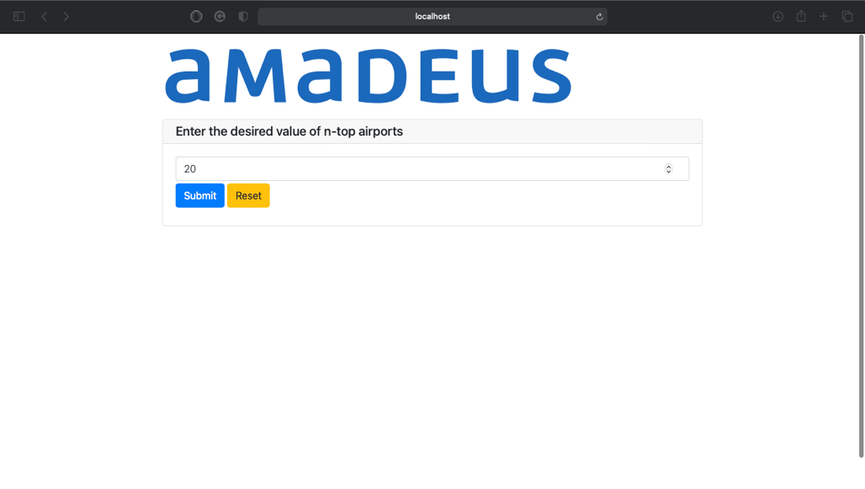

**Step 3:** Wait for few minutes the app will fetch the requested data

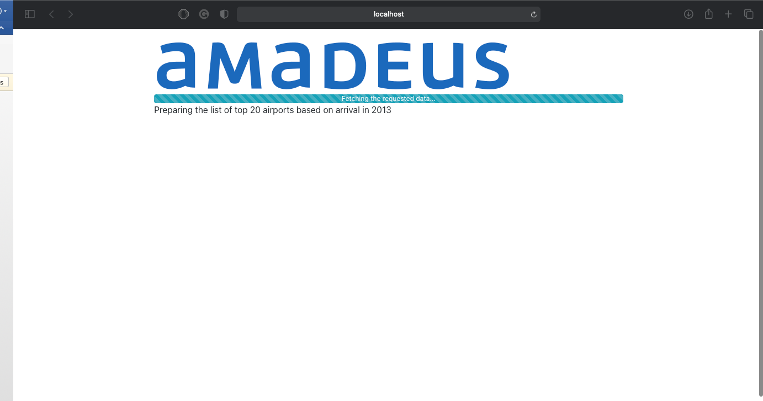

**Step 4:** If the operation is success, a success message will be displayed with the json output file URL

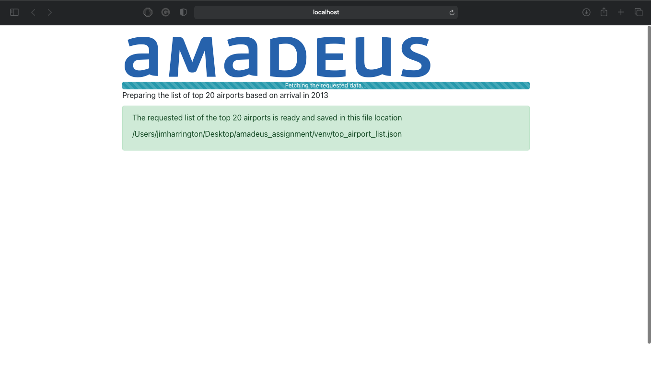

Thank you